Name________________________
Class_________________________
Challenge: Use Glogster to create an eye-catching glog presenting your president research. Publish your glog by printing the finished product in color and posting it to our school’s website.
Tech Tools: A Web 2.0 tool called Glogster and Britannica School Edition.
Getting Started: Choose an American president that you would like to know more about.

Task #1: Researching your president
- Go to Britannica School Edition and select Elementary School View This Level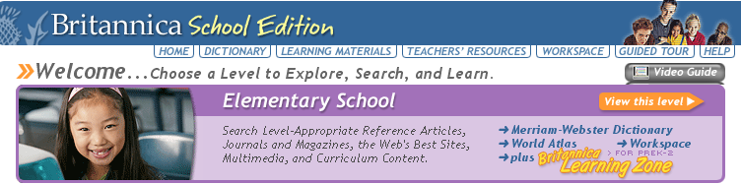

- Type in the name of the president you are researching in the search box and select Go
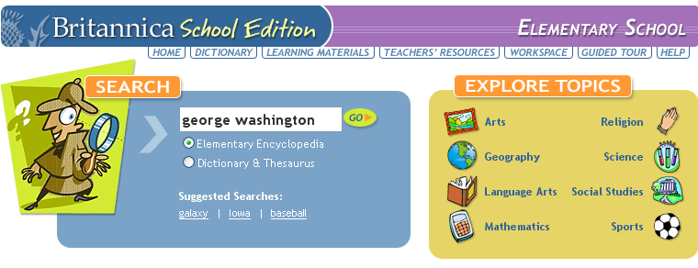

- Select the information that best fits your search topic (There may be many results. Some of them may not be information on your topic)
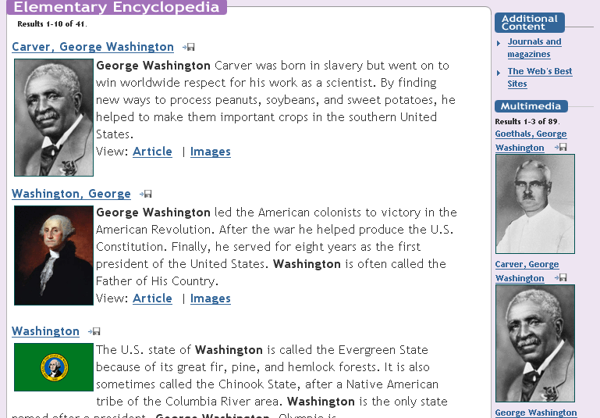

- Use information found in search to fill in your Presidents’ Day Project assignment sheet that your teacher gave you.

Task #2: Making your glog

- Go to Glogster. Select Login at the top and enter the username and password that Ms. Calma gives you.

- Select Create New Glog
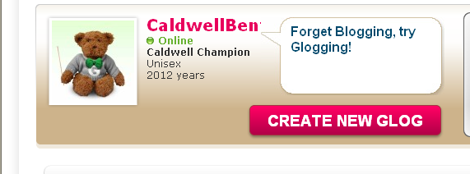

- Select Save or Publish
Save Here
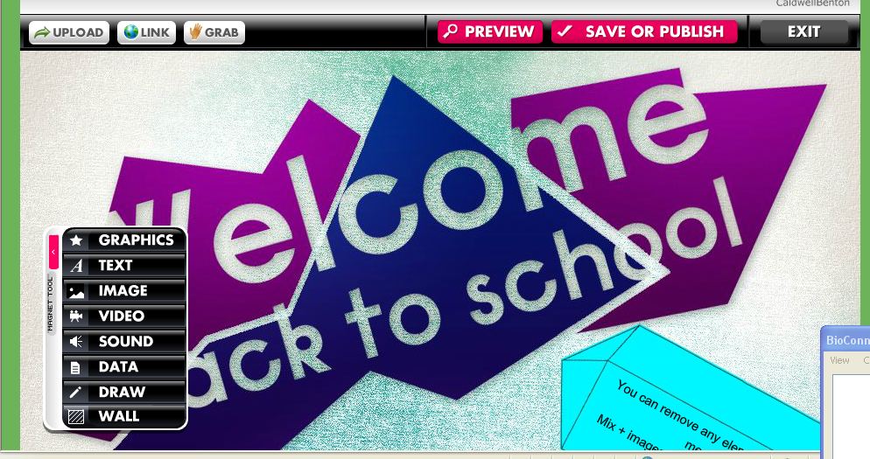
Tool Bar Here

- Save your project as your username (example: ncalma). Write in the tag box the name of the president you are researching.
- Select Save
- Select Continue Editing
- Use the tool bar to design your glog. Remember to include all of the information required by your classroom teacher as listed on your Presidents’ Day Project assignment sheet

Presenting in creative ways: Some ideas of what you can include on your glog

A picture of the president
A video of the president
A wordle of the president
A blabber of the president
A tagxedo of the president

Remember to:
Cite your information, images, videos, ECT (Give credit where credit is due)
Save and save often

