Name:

Class:

**Challenge:** Use a variety of technology tools to create an eye-catching advertisement for a favorite book you’ve read from the Library Media Center’s collection. Publish your  
 ad by printing the finished product in color and posting it to our school’s website.

**Tech Tools:** A Web 2.0 tool called Wordle, Microsoft Office Word, Microsoft Office Publisher, and Microsoft Office Picture Manager

**Getting Started:** Think carefully about the book you would like to advertise. Consider choosing a book you remember clearly and/or really enjoyed.   
*Other guidelines:* Every student should choose a unique book; no two students should work on the same advertisement. The book must be a title from Ringgold’s library.  
You will need the **actual** book (or a copy of it) for work sessions.

**Task #1: Using the Wordle Template**

1. Download the file “WordlePlanningListDoc” from your desktop.
2. Type your name beneath the title.
3. Go to the Microsoft Office Button; choose “Save As.” Name the document your name and the books name (example: ncalmamudshark) and navigate to your “Documents library” before clicking “Save.”
4. Now, begin adding words to advertise your book. Use the list below to get started, but feel free to add additional descriptors.
5. Use the actual book to locate words that  
   fit each category. Please ***only type on the left side*** of the  
   template until we discuss Task #2 as a class.

***Your Wordle must include the following:***

* Title of book
* Author’s first and last name
* Setting
* Main characters’ names
* Genre
* Words to describe the plot and main events in the story
* Feelings and emotions you had while reading this book
* Any other words you think are relevant to the book

**Task #2: Using the “Tab” Key to Type “Wordle Style”**

1. After brainstorming words on the ***left side*** of the template, use the “Tab”  
   key to move them over to the ***right side*** of the template. (This is much more  
   efficient than using the spacebar!)
2. Join words that **must stay together** by using a tilde. *This is a tilde* **~**

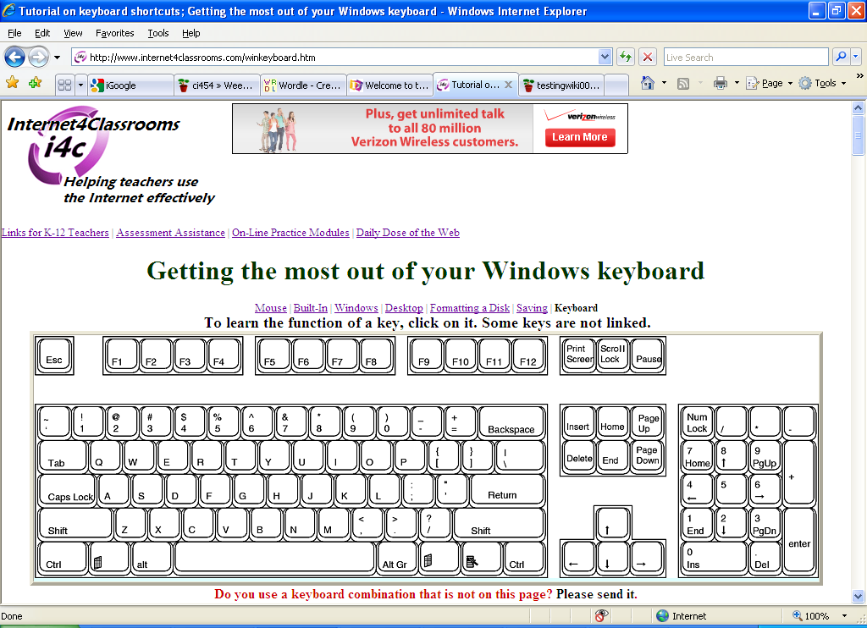**Tip #1: To keep two or more words together, use the ~ symbol.**For example, to keep “Author Andrew Clements” together, type:

Author~Andrew~Clements 🡪Author Andrew Clements  
 **Make the ~ symbol by pressing “Shift” and the key to the left of number 1.**

**Tip #2: Quickly repeat the same word/phrase in your template by using  
two shortcuts: To copy, press “Ctrl + C.” To paste, press “Ctrl + V.”**

Your final product for Task #2 should be a full page of copied/pasted words. Click **“SAVE”** before continuing to Task #3.

**WARNING!**  
All of the steps in Task #4 must be completed within one class time; ***you cannot save online!***

**Task #3: Create your Wordle**

1. Go to **http://www.wordle.net/advanced**.
2. Copy and paste the text from your “Advanced Tab List” into the Wordle box.  
   Click “Go.” (If you see a red “X,” please raise your hand for assistance.)
3. 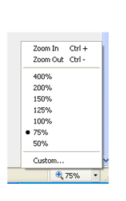Adjust the view of Internet Explorer in the lower-right corner so the entire  
   Wordle can be viewed. **Choose 75%.**
4. Click the “Randomize” button to get a sense of how your  
   Wordle can look.
5. Experiment with the font, layout, color, etc. using the  
   drop-down menus.
6. 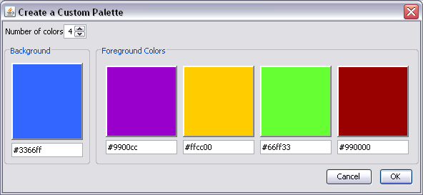Customize your Wordle’s colors  
     
   by choosing “Edit custom   
     
   palette…” under the “Color”  
     
   menu. Click one of the square   
     
   areas to select a specific color.
7. Press “Print Screen.”
8. Open Microsoft Office Publisher.
9. Press “Ctrl + V” to **paste** in the screen capture.
10. **SAVE** the file using the title’s name, your first name, and the word “Wordle.”  
    Example: MudsharkNatalieWordle

**Task #5: Edit the Wordle Picture in Publisher**

1. Click on the Wordle screen shot to activate the editing tool bar. Click the “cropping icon”:
2. Crop the graphic to show only the Wordle.
3. Go to [www.google.com](http://www.google.com) and click “Images.” Search for an image of the book.
4. Copy and paste the image into Microsoft Office Publisher.
5. Use Word Art or a text box to add your first name; adjust the font, color, and size as needed.
6. Press and hold the “Ctrl” key; click every part of your book’s advertisement. Then, go to  
   “Arrange” 🡪 “Group.”C:\Users\obertsa\Desktop\MicrosoftOfficePictureManagerIcon.png
7. Finally, copy and paste the grouped item into Microsoft Office Picture Manager  
   - Go to File 🡪 Export .

-Look on right hand side of the screen.  
- Choose “JPEG” from the drop-down menu.  
- Save it to your H: drive with the book’s title and the word “Export.”

Example: MudsharkNatalieExport

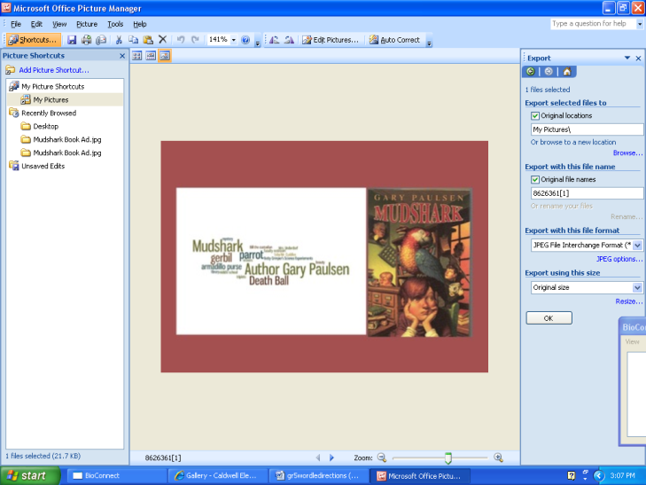

**Congratulations! You are finished. I can’t wait to see all of your AWESOME projects!**

These are adapted instructions. Original instructions found at http://readingtech.wikispaces.com/Wordle+Book+Adshttp://readingtech.wikispaces.com/Wordle+Book+Ads